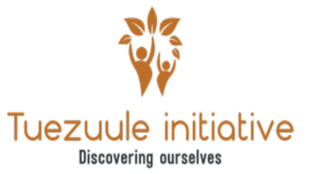
Postal Address: P.O Box 2889, Wakiso Phones: (+256)0772542470, 0755467105
Location: Jandira-Katende, Njuba close Email: tuezuuleinitiative1@gmail.com

ANNUAL REPORT
FY 2021

Message from the Executive Director.
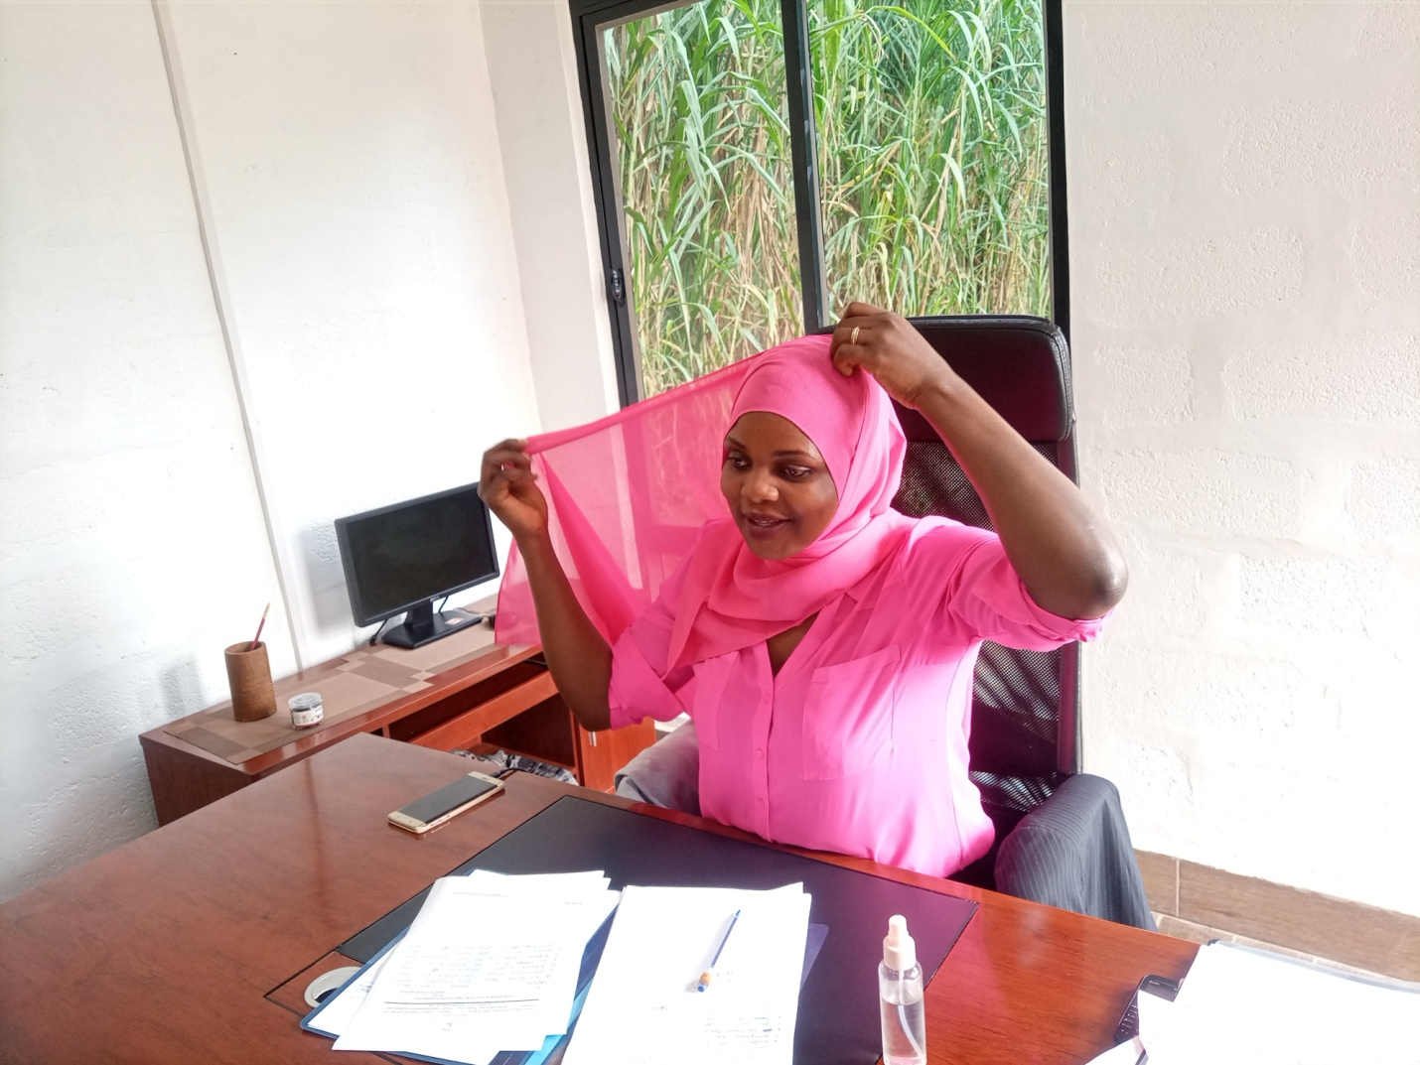
Dear Friends, Volunteers, well wishers and passionate supporters;
We are living through an unprecedented moment in time, but what gives me hope is our equally unprecedented commitment to responding to the needs of the under privileged adolescent mothers, young girls at the verge of dropping out of schools and desperate marginalized vulnerable women in Kasanje Town council, Wakiso District Uganda at-large. Within the days of the World Health Organization declaration of the Covid19 as a global pandemic, Tuezuule Initiative launched a Women and Girl child empowerment focus projects to address the urgent and emerging basic needs of the women communities.
We appreciate all the different kind hearted people across our region, Country and abroad that have extended up their hearts to help the vulnerable women through our grass-root community based organization.
Between May 2021 and November 2021, Tuezuule initiative disbursed approximately 35 Million Shillings in response to the fight against gender based and or domestic violence, Unhealthy menstrual management practices, Unemployment and poor standards of living (for women and girls) in our very own community of Jandira-Kasanje; Wakiso District.
Since the birth of Tuezuule initiative, it has helped donors, well wishers and humanitarians to transform passion into impact on the causes they care about most. We are mindful that every money we get represents the dream, passion and investment of a Donor to strengthen the Girls and Women in the marginalized communities as well as improving their health and quality of life. Whereas the needs and the incredible potential of the young girls and women in the marginalized communities have never been greater. Every day we see impact of our Donors’ generosity and investments. The lasting impactful change we want to see will take time. That’s why Tuezuule Initiative invests/targets for the long term (sustainable impacts). We can do this because of the incredible generous faith and foresight of our supporters.
To all our Donors, Advisors, supporters, non-profit partners, local community authorities Volunteers, well wishers and others who have let us share in their generosity and on behalf of our dedicated and talented board, I offer my sincere gratitude. Thank you for inspiring us and for joining us in supporting women and building the young girls of Kasanje Town council together.

MISSION, VISION AND VALUES
Tuezuule Initiative was established and founded with a mission to include the girl, young mothers, vulnerable women and youth generally into an inclusive mainstream school environment, both formal or vocational and other livelihood support skills while ensuring healthy lives.
With a great Vision, the founders of Tuezuule Initiative envisaged that the organization was to empower the girl child, Young/Adolescent Mothers, Vulnerable women and the Youth generally through formal education (sponsorships), vocational training (Hands on skills workshops) health (camps) and livelihood support skills such as Hygiene, Sanitation, indiscriminative representation etc that will break the cycle of poverty and all its associated vices including but not limited to Child early and or forced marriages, Gender and or Domestic violence, Unemployment, Poverty, Economic dependency etc with in Wakiso, Mpigi, Entebbe and Uganda at large
Our core values are;
- Equality, advocacy and Safety
- Accountability, transparency, support and respect
- Community, empowerment, diversity and innovation
- Lastly, Integrity, Balance and commitment.

MILESTONES
Date | Achievement | visual
11/May/2021 | Licensed to operate as a CBO under the DCBS (Directorate of community Based services)

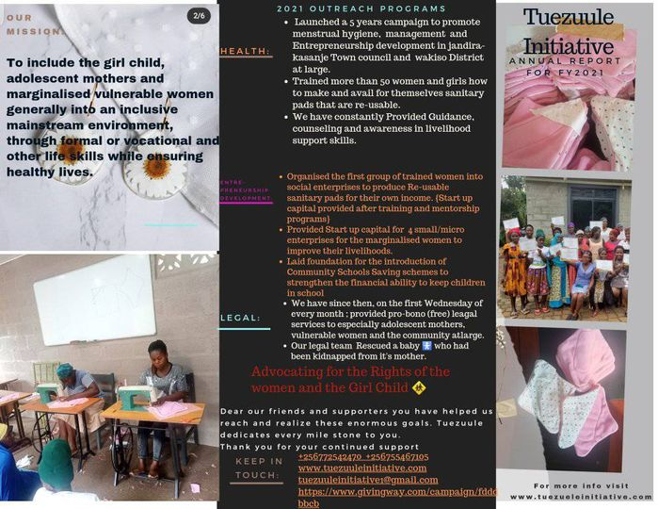

PROGRAM UPDATES
PROGRAM1: MENSTRUAL HEALTH AND MANAGEMENT
Upon its foundation/Initiation, Tuezuule Initiative launched a 5 years campaign to promote Menstrual Health, Management and Entrepreneurship development for the vulnerable adolescent mothers, out of school girl children, young girls and the marginalized elderly women in Kasanje Town council Wakiso District and Uganda at-large.
Under Menstrual Health and Management, Tuezuule initiative has initiated and set up health camps, counseling sessions, awareness creation and above all embarked on training how to make Re-usable sanitary pads to promote and meet up with the basic menstrual necessities for the young girls, poor teenage mothers and the vulnerable elderly women in the community.
As a result of the immense poor menstrual health, management and unavailability menstrual basic necessities of women and girls in the communities due to poverty, Tuezuule Initiative has since then organized the successfully passionate trained women and girls into social income generating enterprises , to make and produce Re-usable sanitary pads for their hence improving their standards of living amidst the day by day increasing costs of living through economic empowerment and independence.
Our First group of over 60 people (in the aforementioned categories) were recruited and participated in this project (guidance and counseling sessions, Health Camps and Training how to make re-usable sanitary pads) and they acquired the necessary knowledge and skills for a period of 3 months from 1st September 2021 to 15th December 2021.(that was our first group)
This first session was successful and those who exhibited passion and perfection were awarded with certificates of completion.
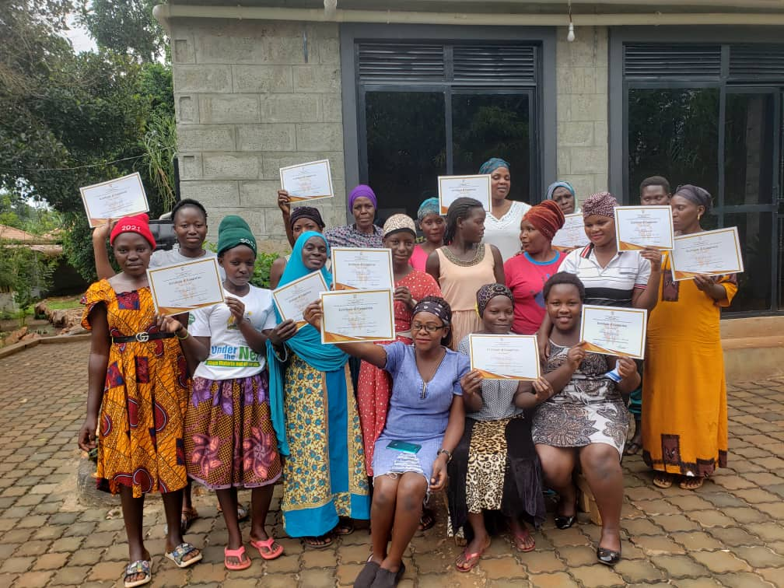
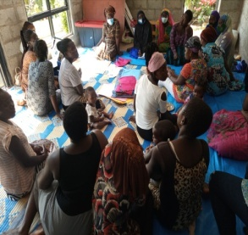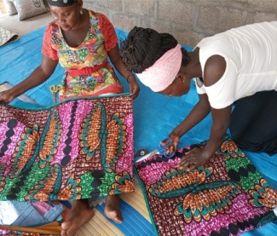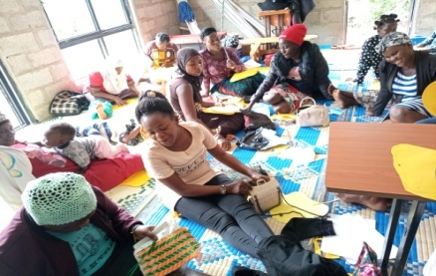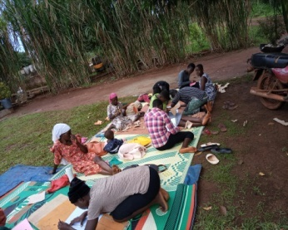
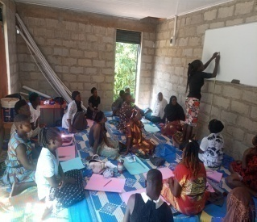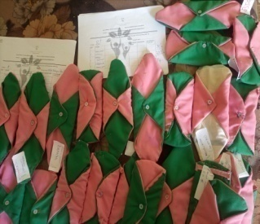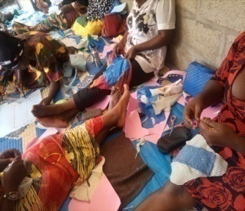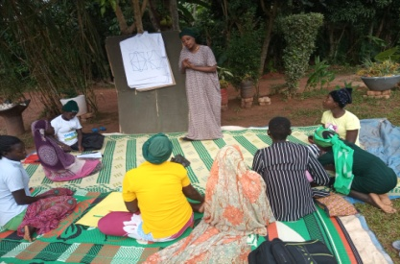
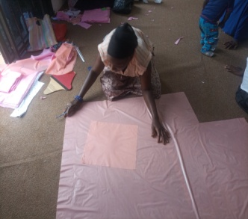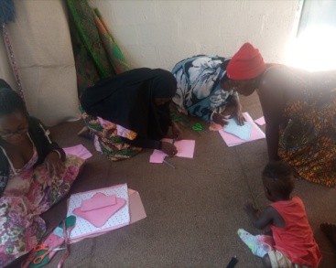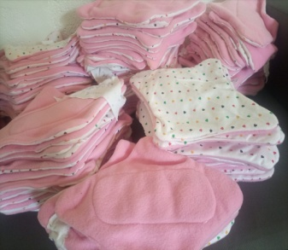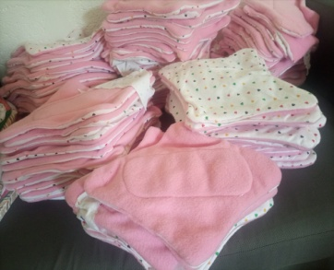
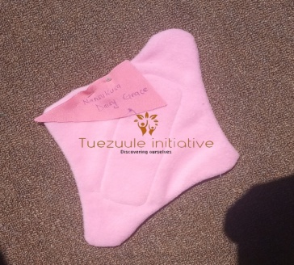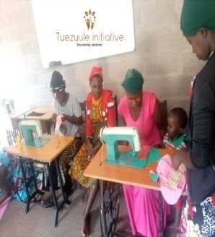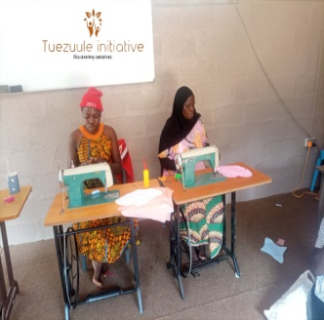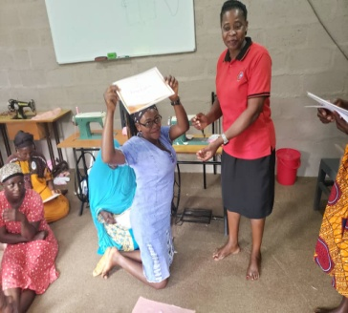
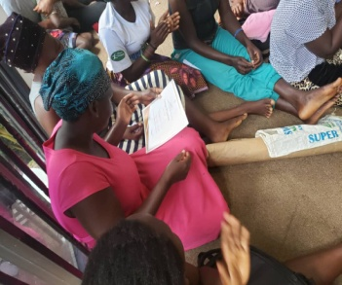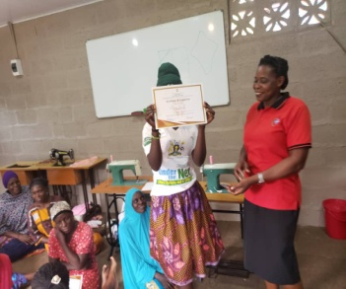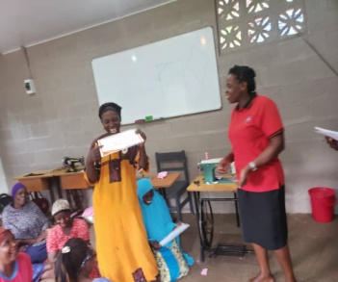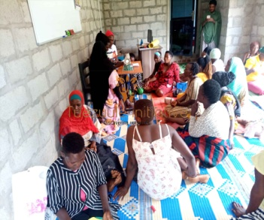

For more info and trace about this program Kindly Visit www.tuezuuleinitiative.com

PROGRAM 2: ENTREPRENUERSHIP DEVELOPMENT
Our project components inter-link and we were able to provide start-up capital for 4 micro enterprises for women. Whereby 2 grocery stores were established by our granted women, a saloon was started and supported a local tailoring business was empowered for our ladies. We believe that this is improving their self esteem, economic independence, and improve life style.
We designed a business model for making re-usable sanitary pads whereby the passionate trainees are organized into social economic enterprises so as to create a source of income and improve the quality of lives of the participants.
This has helped us to sustain our achievements so far.(we hope to grow this company bigger in 2022 so as to create more employment opportunities for the unemployed adolescent single mothers, vulnerable marginalized elderly women and the general various communities at-large hence this will not only help to curb the rampantly increasing poverty but also reduce on the vices it causes in the community such teenage pregnancies, early and or forced marriages, among other vices
PROGRAM 3: PRO BO NO LEGAL SERVICES
In partnership with the MBAJJA&CO.ADVOCATES, Tuezuule initiative started offering free legal services to the vulnerable marginalized women, girls and the community generally every first Wednesday of the month. This also covers men children and the community at-large.
Effectively, our legal team managed to rescue a baby that had been kidnapped from its mother by the mother in-law in conspiracy with the baby’s father.
FINANCIAL STATEMENTS
YEAR ENDING 31St JANUARY
REVENUE AND OTHER SUPPORT | AMOUNT(Shs)
Board contributions | 48,100,000/=
Community Contributions | 294,000/=
Individual Contributions | 2,010,000/=
Charitable campaigns | 176,000/=
Investment income | 0
TOTAL SUPPORT & REVENUE | 50,580,000/=
EXPENSES
Program Services/Grant Collection | 35,000,000/=
General and Administrative | 16,100,000/=
TOTAL EXPENSES | 51,100,000/=
CHANGE IN ASSETS
Net assets (beginning of year) | 0
Net Assets at the End of year | 31,360,000/=

SPECIAL MENTIONS
A special mention goes to Mr. Katende Steven (Team Leader @ kisoboka Africa) and the kasanje Town council administrators including but not limited to the office of the Town Clerk and the Community Development officer who besides warmly welcoming our infant organization to start operating in their area but also provided all the necessary support (documents) for making our humanitarian activities a success. We still count on their financial and any other forms of support to create a lasting positive impact in the various communities of the Town council.
Not leaving out the LC1 chairperson of Jandira village and the entire leadership team of the village that has been forever supportive towards the success of our first part of the launched 5 year campaigns.
In conclusion, elsewhere there is a spirited performance from the Jandira Domiciliary clinic, our programs director and projects coordinator. Thankfully everything was handled despite all the arising crises.

